Did I ever tell you all the story of how I scammed a fake employment company? No? Well pull up a chair and leggo!

I applied for an online job through a trusted website. It costs $300 to post a job ad for one month so I assumed this particular position was legitimate. The position was for a Remote Graphic Designer for an actual company called Clearwater Paper Corporation and after doing my research (looking up both the company website and the name of the job poster on LinkedIn) I decided to apply.

A few days later, I received an email stating they wanted to interview me. Excitement washed over me as I continued to read their response. They wanted me to e-mail the HR recruiter who would be handling my interview. Ok! Then I saw they wanted me to reach out to her via Google Hangouts. I should've been suspicious right then because, who STILL uses Google Hangouts?! However, I assumed that since this isn't a well-known company that maybe they were still using an outdated collaboration hub.

I interview, all in chat messages, with 'Stacey' who types in broken English and would disappear for up to 15 minutes in-between responses. I assumed that she may have been interviewing several candidates at once and brushed off the long lapses. At the end of our interview she tells me she's going to forward my responses to the hiring managers and to 'please stand by'. I figured she would say ‘they’re going to spend the following week looking over everyone’s responses and I should expect to hear something by the end of that week’. That’s not what I heard. I actually didn’t hear anything from Stacey for just about 7 hours. I FINALLY received a reply informing me that we would 'meet on Tuesday for an update'. (Monday was a holiday) By now, I’m pretty certain that this position isn’t real but decide to move forward just in case I was wrong. Because it WAS my first time interviewing for a remote position.

Tuesday rolls around and Stacey tells me I've been hired for the Graphic Designer position. She tells me she will send over my Employment Offer letter and I would need to sign it right away. She also asks if I have a checking account so that I can get my paychecks direct deposited. I’d attempted to call the actual company and the actual HR Recruiter that goes by that same name but to no avail. So I admitted that I felt this entire thing felt a bit sketchy and asked if she could verify the validity of this position. She says ‘everything will be revealed during training’ and that if ‘I were truly uncomfortable I could decline the offer’. Nah, now I want to see if they’ll send ME their bank information.

Wednesday I get my 'offer letter' complete with the company logo (albeit stretched out and warped) and signed at the bottom with the company's actual head of Human Resources. I inform Stacey I received the letter and she asked me to sign it, scan it and e-mail a copy to her along with my driver’s license. I inform her that I’d like to speak to someone IN PERSON before signing anything and ask if she’s at her desk.

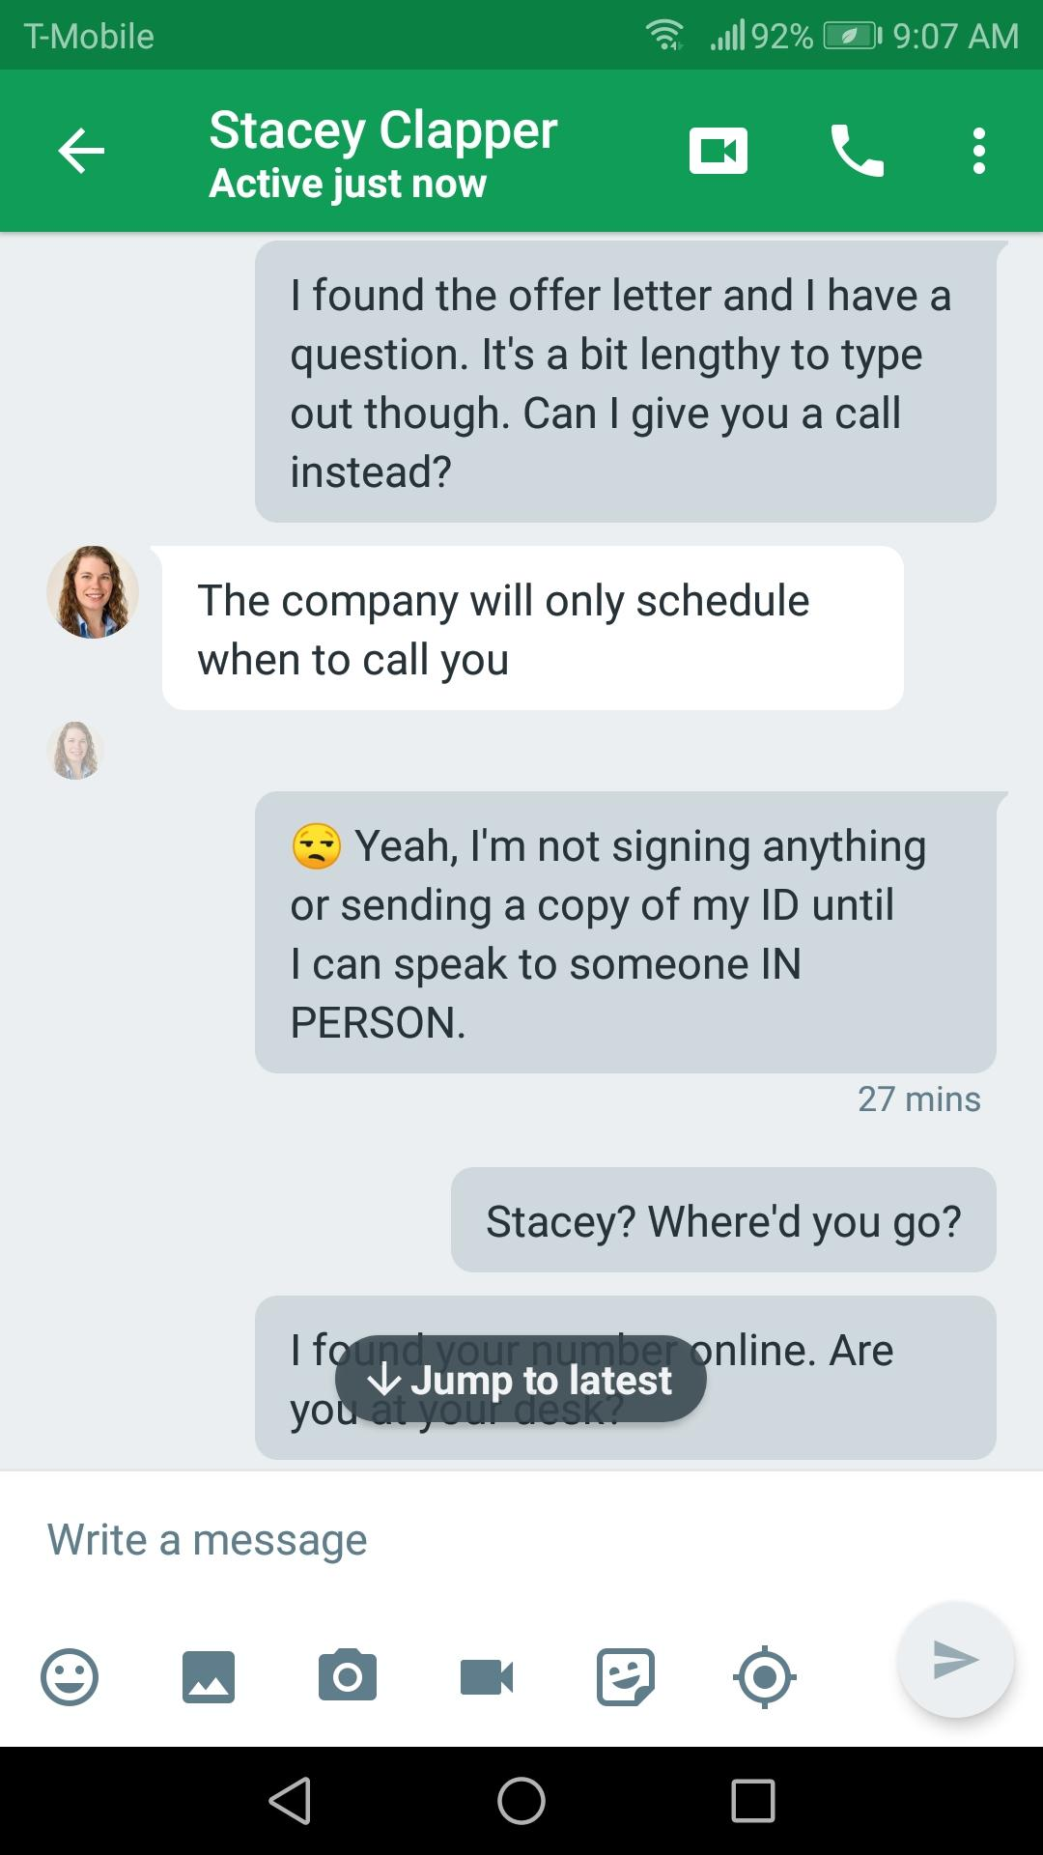

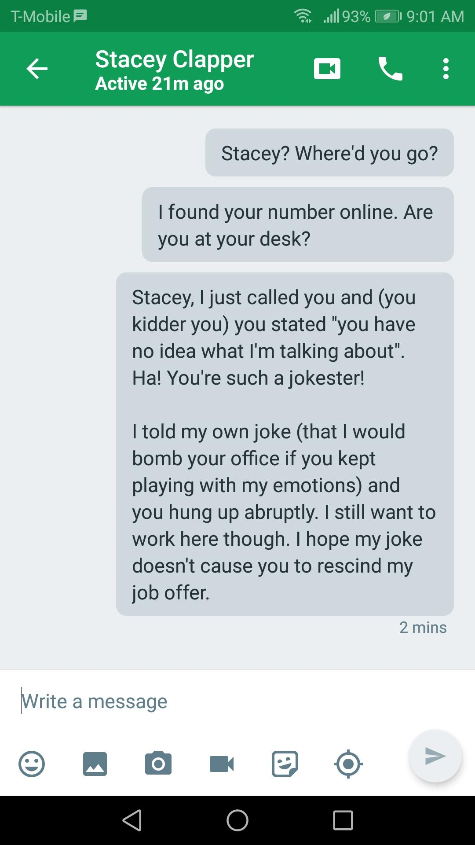

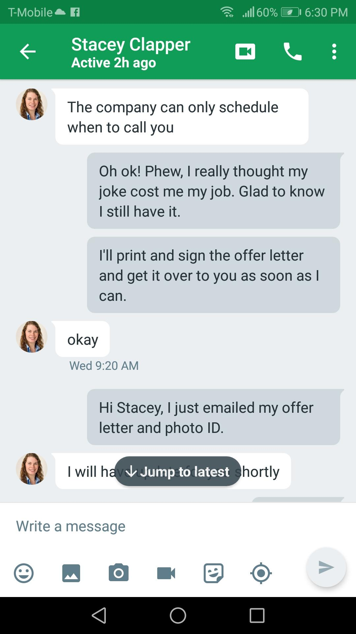

Thankfully, I still had my ‘job’. I sent over a signed copy of the employment offer and my ‘drivers license’:

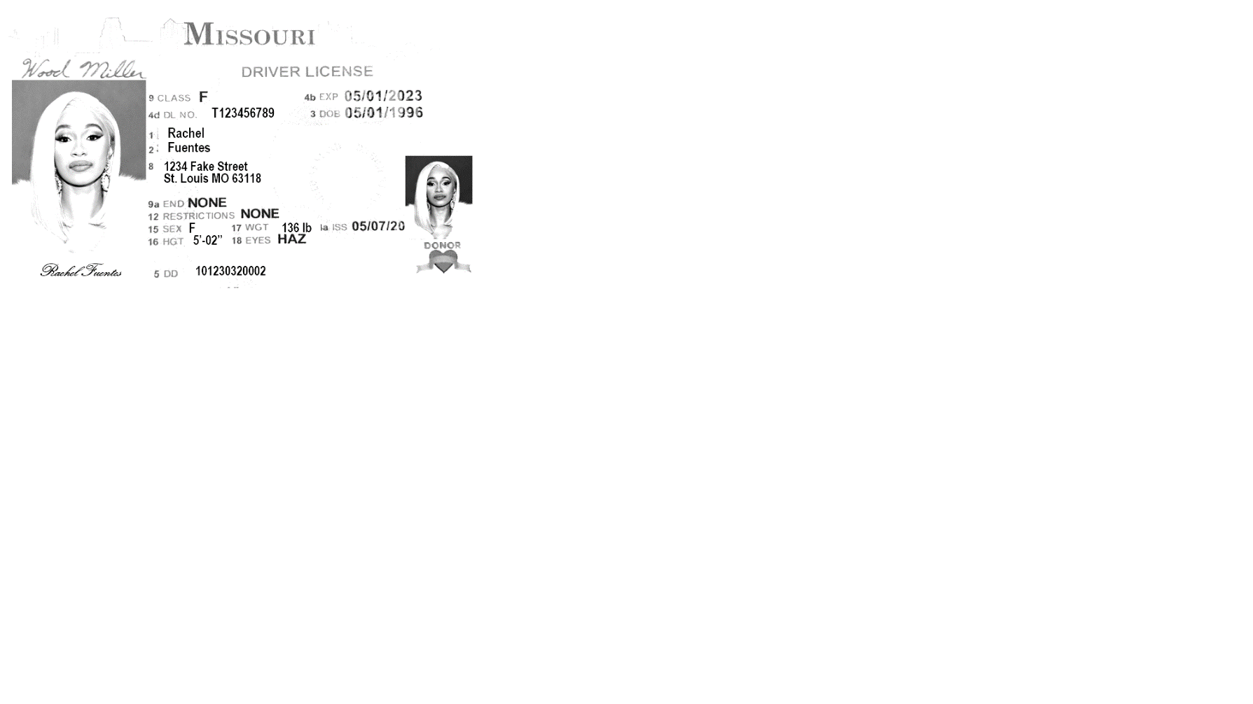

These morons didn’t realize that not only is that Cardi B, but my address is completely different from what’s listed on my resume! They didn’t care, they thought they had a sucker on the line.

She then asked again if I had a checking account because they were going to send me a check for my office equipment.

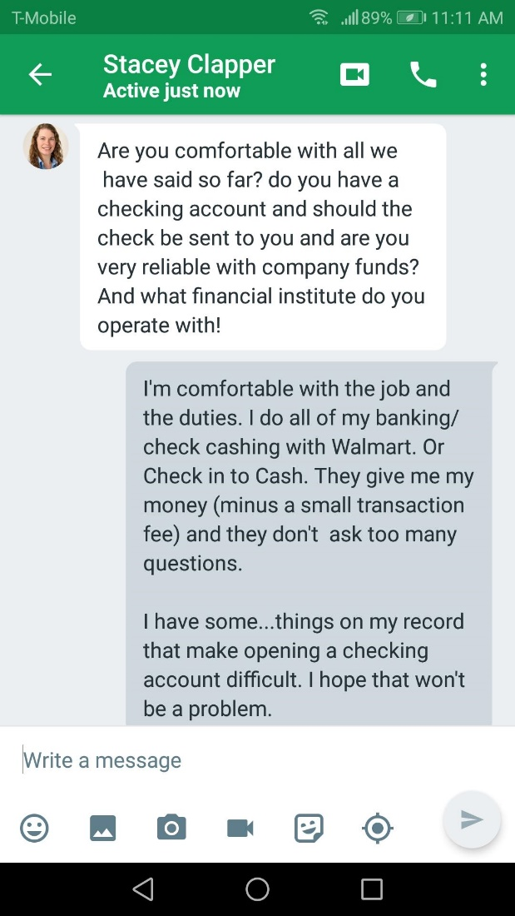

Because they had a copy of my resume, they DID have my real name and address. That meant they knew exactly where to mail that B.S. check. But I figured that was basic info that you can find on anyone.

Thursday the 'check' arrives. The check appears valid but the information typed on it is not. This position was supposedly located in Spokane Washington, but the check came from California. Stacey tells me to put the check into my checking account and send her a copy of the receipt once I'd deposited it. I found a fake deposit receipt online, edited it so that it looked like I actually made a deposit and sent that photo to Stacey. She responds with '*let us meet tomorrow by 8am for update'*.

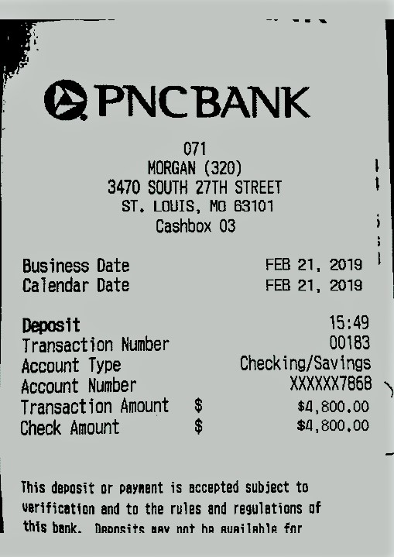

Friday, Stacey instructs me to use the newly deposited funds to purchase a cashier’s check in the amount of $3,800. Afterwards, I am to take the check to a Chase Bank and deposit it into their account. Despite all of my clowning around, they STILL gave me their bank account info. I told Stacey I was headed to the bank, but I couldn’t make it, I got caught up:

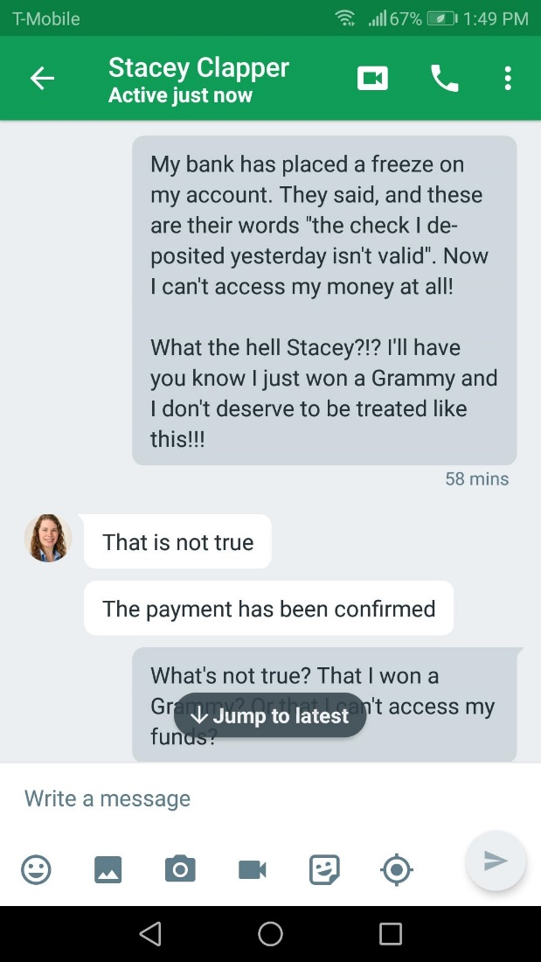

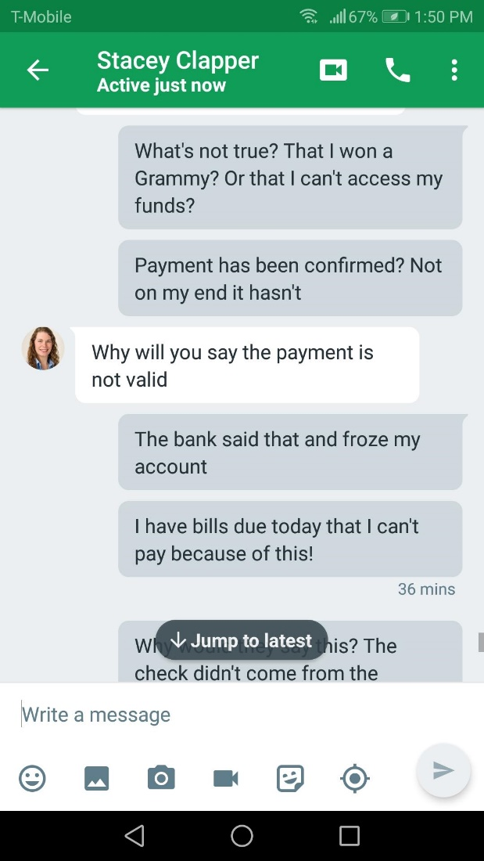

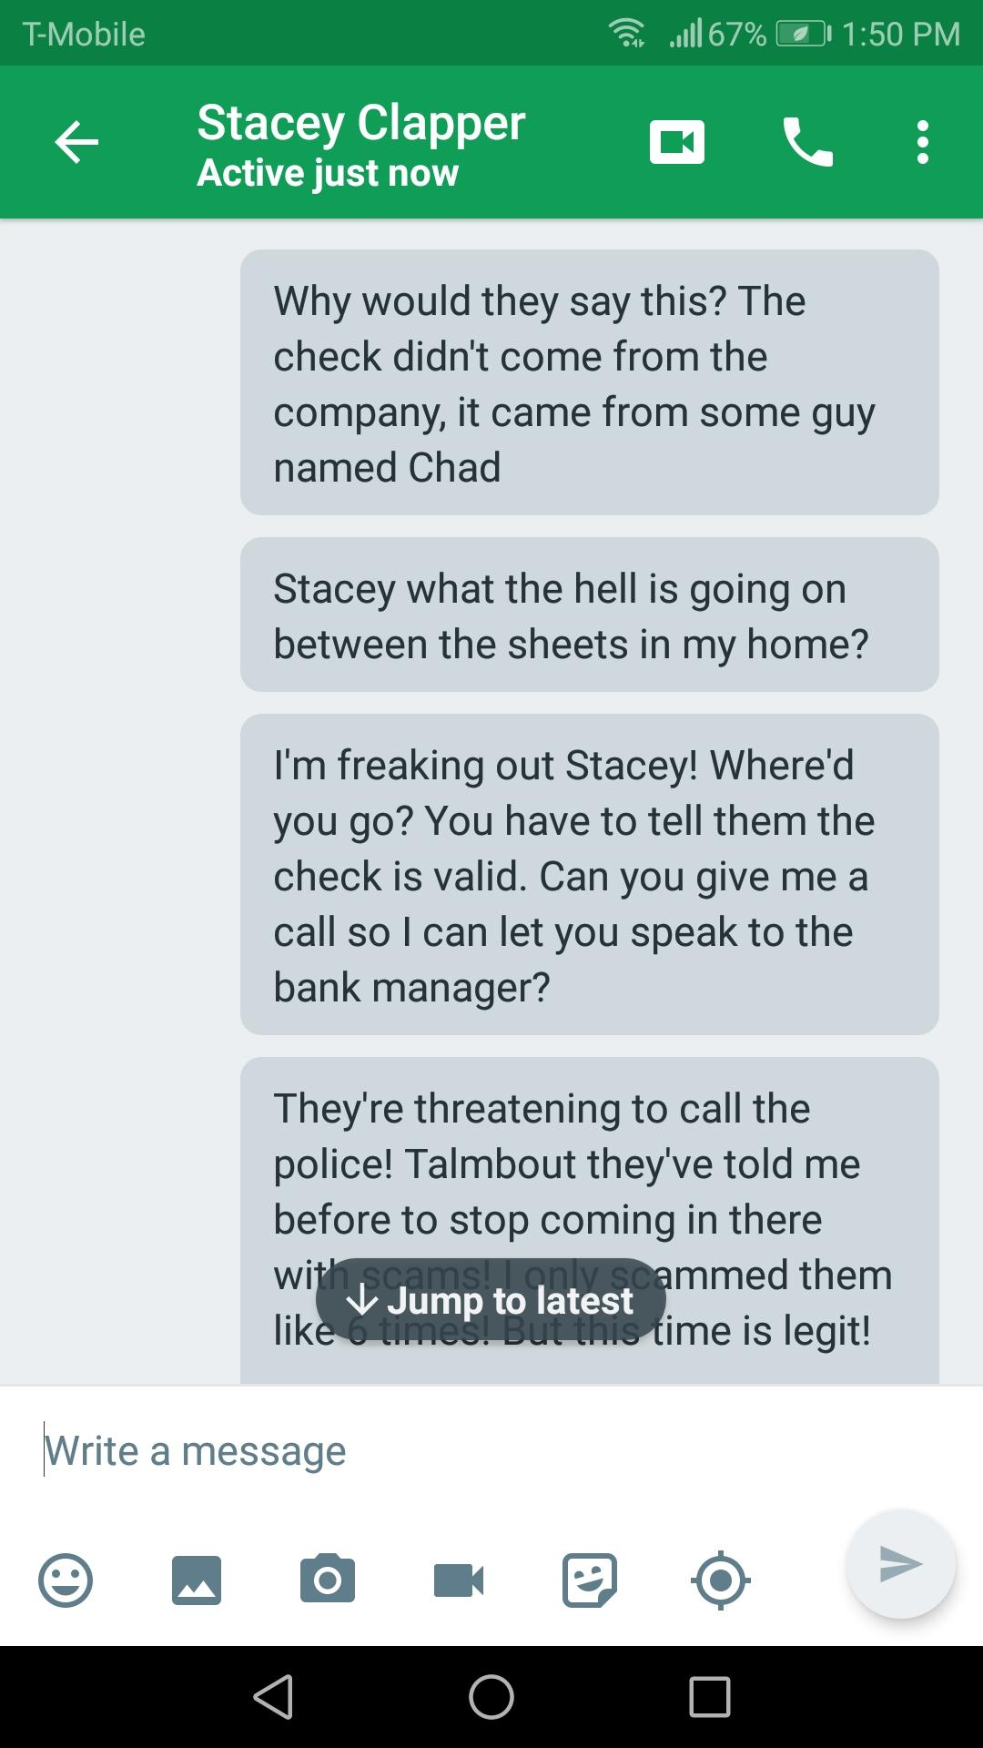

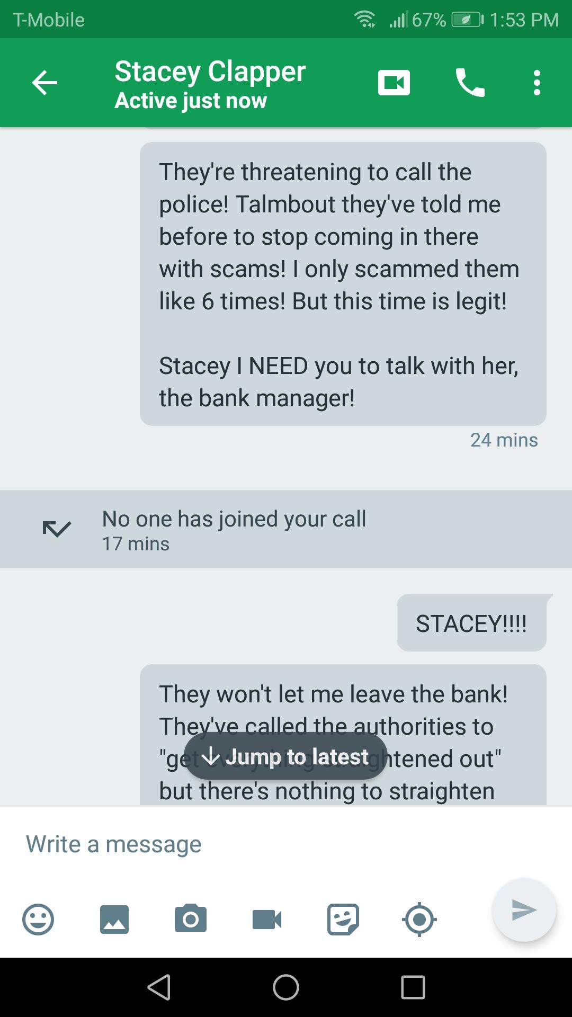

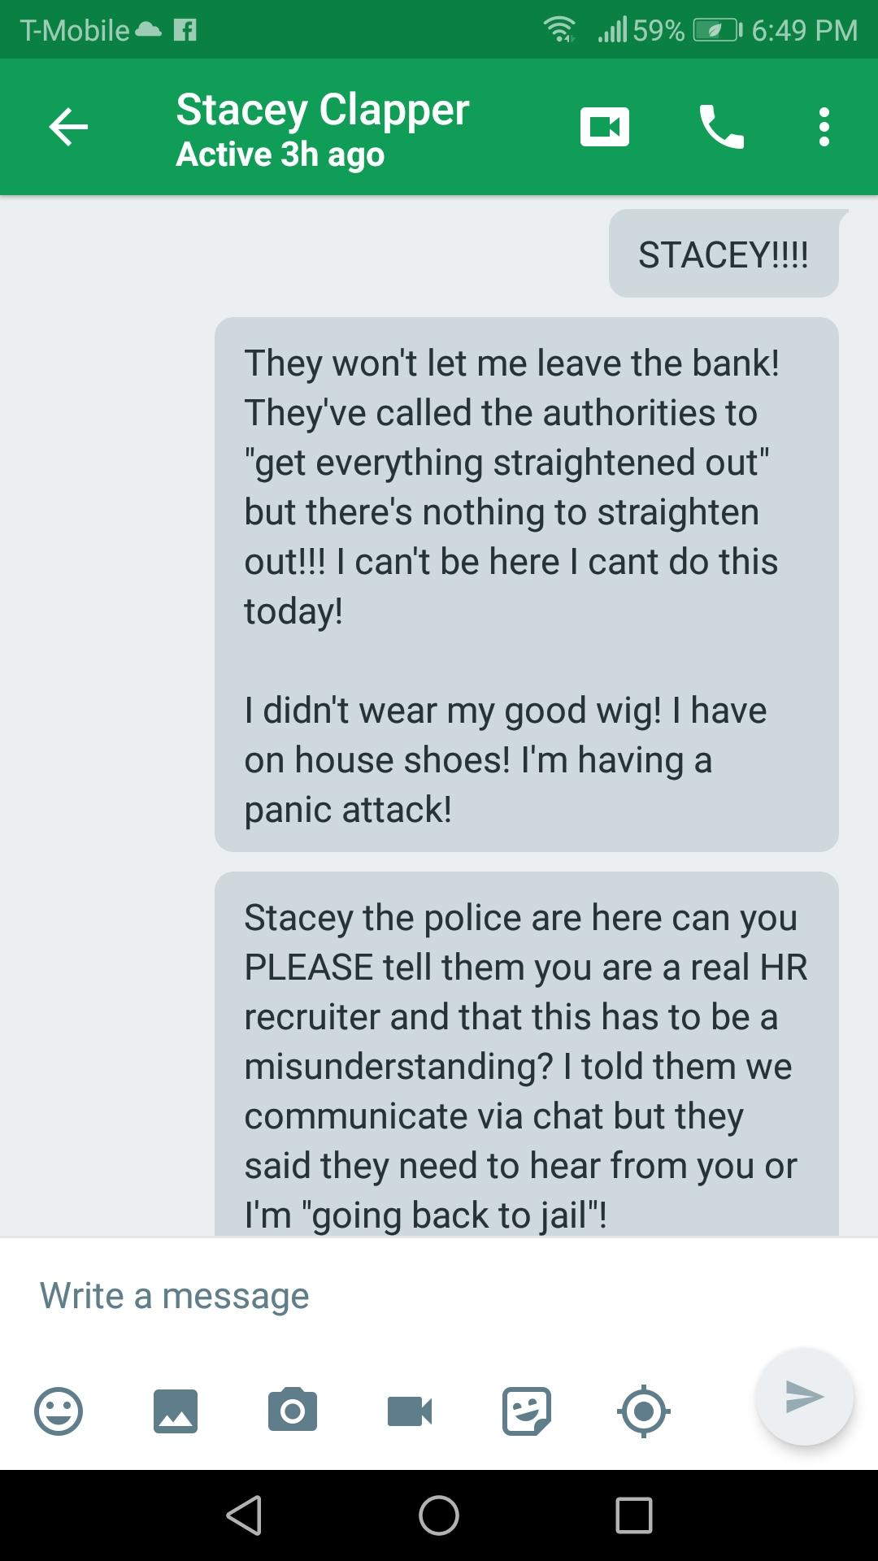

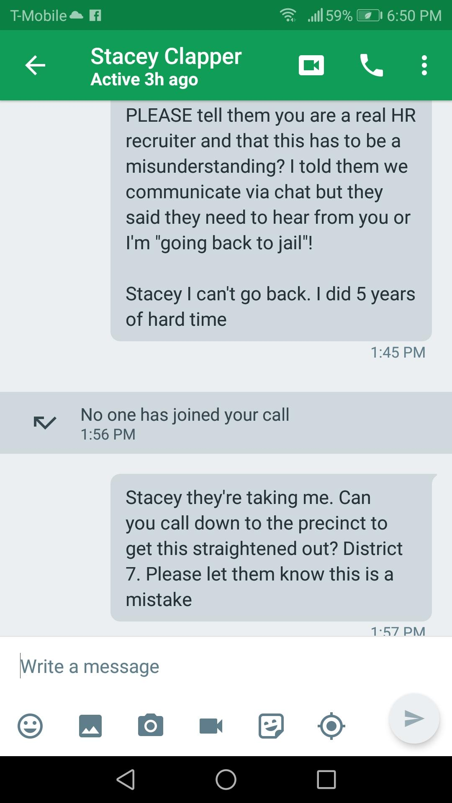

I haven’t heard a peep from Stacey since. She’s just gonna let me ROT in jail! I sent all their information to the FBI's Cyber Crime Unit. I hope they catch them. I’m certain they’ve succeeded with this scam and stole from some innocent people. It's a sucky thing to steal from folks and even suckier to steal from people looking for work. It's like kicking them when they're down.

And that's my story. How I finessed some losers out of their account information. Now, who wants to buy some Amazon gift cards?! I know a guy who's buying!